About the Coursemasters
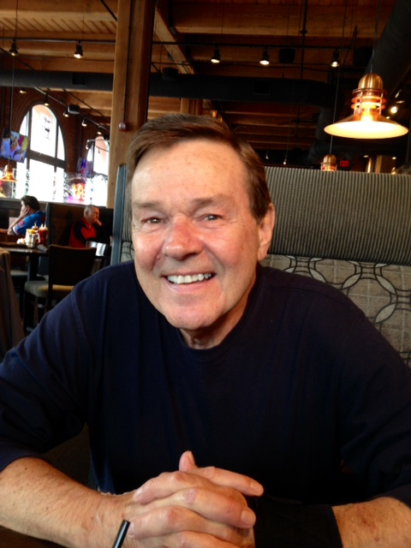To add a picture:
1. Click in this box.
2. Click the Insert - > Picture.
3. Find your picture
4. Delete this text.
If you don’t want to add a picture, delete this box.
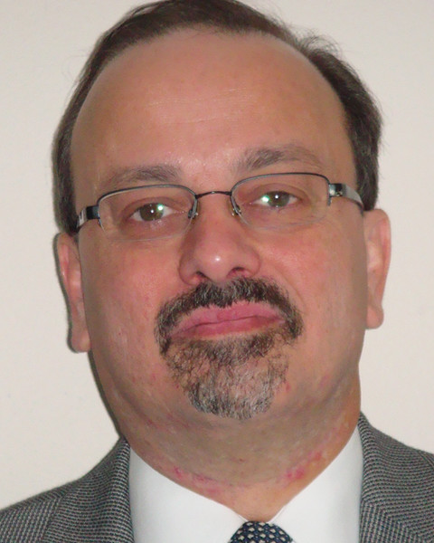
Contact Information:

Name Carl Siekmann, MBA Name: Peter Takes, Ph.D., RAC, FRAPS
Phone number: 314-479-7222 Phone number:
Email address: csiekmann@earthlink.net Email: ptakes@wustl.edu
Campus office: n/a Campus office: n/a
Preferred method of contact: email Preferred method of contact: email
Virtual Office Hours: by appointment Virtual Office Hours: by appointment
In-Person Office Hours: by appointment In-person Office Hours: by appointment

Coursemaster(s) Biography:
Prof. Siekmann: I am an experienced pharmaceutical executive with extensive experience in business and corporate development, general management, and marketing with companies including: Bristol-Myers-Squibb, Abbott Labs (now AbbVie), Adria Laboratories (now Pfizer), and Bock Pharmacal (now Sanofi). Most recently, I was co-founder and CEO of Zanogen Biosciences, a cancer therapeutics biotech company. Currently, I have my own biopharma consulting firm, BioAdvisory, and teach courses in drug development and strategic partnering at Washington University School of Medicine.

Dr. Takes: I am a scientific and regulatory professional with experience in laboratory and research management, regulatory affairs, quality assurance, clinical trials, clinical & corporate healthcare compliance, in vitro diagnostics, medical devices, bulk pharmaceuticals, and academia, supported by over 40 scientific, clinical, and regulatory publications and presentations. I spent 14 years at Stereotaxis, Inc., where I served as Sr. Director of Clinical & Healthcare Compliance, Clinical Compliance Officer, and Director of Clinical & Regulatory Affairs. This was preceded by 11 years at Sigma-Aldrich Corporation, where I had my own R&D lab, serving as Immunodiagnostics, Hematology, and Histology Program Manager, Director of Clinical Flow Cytometry, and Clinical Studies Coordinator. Before assuming a position as Principal Consultant with Regulatory Intelligence Associates, LLC, I was Vice President of Clinical & Regulatory Affairs and Quality Systems, and Privacy & Compliance Officer at Kypha, Inc. I earned a BS in Biology from Clarkson University, and a Ph.D. in Immunology from Indiana State University, and completed two postdoctoral fellowships at Washington University School of Medicine. I am Board-certified in Regulatory Affairs and a Fellow of the Regulatory Affairs Professionals Society, and Editor-in-Chief of the textbook Global Medical Device Regulatory Strategy (2nd edition currently in preparation). Presently, I hold four faculty appointments, at WUSM, Webster University (adjunct full professor), StLCC, and Lutheran School of Nursing, where I teach courses in biological sciences, device development, science leadership, and regulatory affairs.

Teaching Philosophy:
- Prof. Siekmann: This course requires a fair amount of lecture early on in order to understand the evolution of drug regulation and the methods of drug discovery and development. Where possible, however, I like to employ the Socratic method of questioning and discussing to encourage critical thinking skills and utilize a case study methodology for the last two drug classes. I also prefer giving take home exams. If you correctly answer the question I don’t care what source you use though you are encouraged to rely on the assigned readings and class notes posted on Blackboard.
- Dr. Takes: Prof. Siekmann and I are fairly consistent in our general teaching approach, although there are some slight variants in teaching style, simply reflective of the differences between understanding the overall drug and device development methodology. My exams (2) are given in class, rather than as take-home exercises. Device development is a bit more directly dependent on the regulatory stipulations, and so much of this section is focused on that strategic design.

About This Course

Required Texts (device section only):
King, PH, RC Fries, and AT Johnson. Design of Biomedical Devices and Systems, 3rd Edition. CRC Press, 2015.

The Device section utilizes textbook and supplemental readings provided by the instructor. There is no specific textbook for the Drug section; supplemental readings will be provided by the instructor.

Other Course Materials:
Instructors will provide materials electronically on Blackboard and as hardcopy handouts in class.

Course Description: This course will provide an overview of the commercial development pathways for both pharmaceuticals and medical devices, from inception to market. Class topics will include preclinical, clinical, regulatory, and marketing factors which influence discovery and development of new medicinal products. Through lectures and class discussions, students will gain an appreciation for the role clinical study programs play in the broader scope of product development. Drug development will utilize a case study methodology for the topics of R&D portfolio management and generic drugs. Additionally, each student will prepare a report on a medication or medical device of their personal interest, for an in-depth project.

Goals of the Course: To provide students a clear understanding of the product development process for drugs and medical devices from discovery to commercialization. It is expected that the knowledge gained from the course will be useful in allowing students to position various individual research projects into the broader context of product development, regulatory approval, and eventual market access. The course is not designed to offer specific “how to” guidance for the preparation and submission of specific regulatory applications to FDA, and/or for the specific design and development of particular drugs or devices.

Daily Work/Homework: Complete reading assignments and prepare to participate in class discussion.

Major Assignment Descriptions: Two mid-class exams (device, drug), two final exams (device and drug, respectively), one final project/presentation, each worth 100 points. Course total = 500 points.

Class Participation: Class participation is encouraged and welcomed. The class is considered an inclusive learning environment where we can all learn from each other. Most students are healthcare professionals or research scientists and have unique experiences and a unique perspective to share with fellow students. Of course, all discussion will be civil, respectful, and supportive of this learning environment.

Technology Requirements:
At a minimum, you will need the following software/hardware to participate in this course:

- Computer with an updated operating system (e.g. Windows, Mac, Linux)
- Updated Internet browsers (Apple Safari, Internet Explorer, Google Chrome, Mozilla Firefox)
- Ability to navigate the Blackboard Learning Management System https://bb.wustl.edu/.
- Minimum Processor Speed of 1 GHz or higher recommended.
- DSL or Cable Internet connection or a connection speed no less than 6 Mbps.
- Adobe Flash player (free)
- Adobe Reader or alternative PDF reader (free)

Time Requirements

A minimum of two to four hours per week outside of class should be expected.

Course Schedule (subject to modification)

Date | Topics | Chapter readings
8/30/2018 | Class Orientation and Organization  #1: Introduction to Medical Device Development  - History and Background  - Regulation  - Acronyms, terms, definitions  - Information resources | Chpts 1, 4, & 16
9/6/2018 | #2: Device Design and Development Process  - Design Controls  - Failure Mode and Effects Analysis  - Risk Assessments: clinical & design | Chpts 6 & 12; Chpt 7: 7.4.3, 7.6-7.9, 7.11-7.16
9/13/2018 | #3: Clinical Trials  - Device trial design  - Human factors  - Difference between device and drug trials  - Clinical compliance | Chapter 9
9/20/2018 | #4: Mid-Class Exam – Devices  Regulatory Processes  - United States  - European Union  - Asia & Pacific Rim | Chpt 19
9/27/2018 | #5: Non-clinical testing  - Good Laboratory Practices (GLP)  - Animal studies  Manufacturing  - Good Manufacturing Practices (cGMP)  - Pilot and Scale-up  Marketing & Reimbursement  - Labeling  - Claims | Chpts 11, 13, & 21
10/4/2018 | #6: Post-Marketing  - Requirements  - Studies  - Complaints  - Continuous Improvement  - Sponsored research | None
10/11/2018 | Class Exam - Devices final | None
10/18/2018 | Introduction to medicinal products  - Drug Development Thought Process  - Regulatory History | None
10/25/2018 | Drug Development Process - overview  - Identifying therapeutic targets  - Drug Discovery  - Preclinical Development | None
11/1/2018 | Drug Development – Clinical Development  - Clinical Trials  - Manufacturing | None
11/8/2018 | Mid-class exam – Pharmaceuticals  - Clinical trial metrics  - 2012 FDA initiatives: PDUFA | None
11/15/2018 | R&D Portfolio Management  Vertex Case Study | None
11/22/2018 | NO CLASS – HAPPY THANKSGIVING!!
11/29/2018 | Generic Drug Development  - Hatch Waxman Act 1984  Teva Case Study | None
12/6/2018 | Class Exam - Pharmaceuticals final | None
12/13/2018 | Individual Project Reports  - Written - discussions  - Oral Presentations
 | No final exam

Assessment/Grading

Summary of Course Assignment Point Values:

Device Mid-term 100
Device Final 100
Drug Mid-term 100
Drug Final 100
Final Presentations/ Paper 100
Total 500

Grading Scale: This course utilizes the standard CRTC grading scale. The grade value for each letter grade is as follows:

Grades/sub-grades | Course Points | 4-point scale
A+ (98% to 100%)  A (93% to 97%)  A- (90% to 92%) | 490-500  465-489  450-464 | 4.00  4.00  3.7
B+ (88% to 89%)  B (83% to 87%) – minimum for Core courses  B- (80% to 82%) | 440-449  415-439  400-414 | 3.3  3.00  2.7
C+ (77% to 79%)  C (73% to 77%) – minimum for Electives  C- (70% to 72%) | 385-399  365-384  350-364 | 2.3  2.00  1.7
F | <350 | 0

Penalties for Late Work: There is no set policy; each instance is evaluated on a case-by-case basis by both instructors collectively.

Attendance Requirement for Face-to-Face Course:
In-class participation is an important part of the coursework taken as part of the MSCI or AHBR programs and the clinical research training programs within the CRTC. Students are expected to physically attend at least 75% of class sessions for each course they take. Students whose professional duties or personal circumstances prevent them from meeting this program attendance requirement must receive prior written approval of the coursemaster(s), and agree on an alternate plan to achieve course objectives and earn academic credit.

Technical Support

If you have any technical problems accessing Blackboard please e-mail blackboardhelp@wustl.edu immediately. If you are having problems accessing the videos, modules and other materials e-mail your coursemaster directly or contact the CRTC support staff at crtc@dom.wustl.edu.

Course Policies

Drop Dates:
If the occasion should arise that you want or need to drop this class, please talk with one of the instructors first. You can drop for any reason during the course of the semester, however you may only receive a partial or no tuition reimbursement depending upon how far into the semester you drop the course. See the Academic Calendar for your program for specific dates and reimbursement policies. Note, late withdrawals will also appear on your transcript as a withdrawal.

CRTC Academic Policy Guidelines:
Guidelines regarding CRTC course registration and enrollment, grades, tuition obligation, and academic leave are consolidated in the CRTC Academic Policy Guidelines. Please take a moment to review this document.

CRTC Guidelines for Academic and Non-Academic Transgressions:
By registering for this course you have agreed to the terms of the CRTC Guidelines for Academic and Non-Academic Transgressions. If you have not already reviewed this policy, please be sure to before beginning any CRTC related coursework.

Academic Integrity/Plagiarism:
- Academic dishonesty is a serious offense that may lead to probation, suspension, or dismissal from the University. One form of academic dishonesty is plagiarism – the use of an author's ideas, statements, materials, or approaches without crediting the source. Academic dishonesty also includes such acts as cheating by copying information from another student. Plagiarism and cheating are not acceptable.
- Academic dishonesty will be reported to the Office of the Registrar for possible action. The coursemasters will make an academic judgment about the student’s grade on that work and in that course. The CRTC process regarding academic dishonesty is described in the CRTC Guidelines for Academic and Non-Academic Transgressions.

Writing Assistance:
For additional help on your writing, consult the expert staff of The Writing Center in Olin Library (first floor). It can be enormously helpful to ask someone outside a course to read your essays and to provide feedback on strength of argument, clarity, organization, etc.

Disability Resources:
Washington University is committed to providing accommodations and/or services to students with documented disabilities. Washington University’s Cornerstone: Center for Advanced Learning Disability Resources is the University’s official resource for students with disabilities and students with suspected disabilities. DR assists students with disabilities by providing guidance and accommodations to ensure equal access to our campus, both physically and academically. To learn more about its services, initiate the process of formal documentation and/or to arrange for accommodations, please contact Disability Resources at the start of the course.

Mental Health Resources:
Mental Health Services’ professional staff members work with students to resolve personal and interpersonal difficulties, many of which can affect the academic experience. These include conflicts with or worry about friends or family, concerns about eating or drinking patterns, and feelings of anxiety and depression. See: http://shs.wustl.edu/MentalHealth.

Reporting Policies:
Please also review the CRTC website for policies regarding sexual assault reporting and reporting concerns about bias, prejudice or discrimination.

